Class IV Summary Report
With the renewed resolve to better each class session, the staff took about three weeks off to improve on the material for the fourth and last group of the year. Each member took it to heart to use the input from past participants to gradually better the experience of newcomers. And so classes began on Tuesday September 28th with an upgraded entrance exam followed by the classic meet-and-greet session.
Each participant was asked to share their background, expectations for this training program, and aspirations for the future beyond this course. Having had a lot of interactions with teachers from the previous class, it was evident that the attendees had to be reminded that they are in this intensive program for a limited time and should aim to make the best of this opportunity and think beyond the class to maximize its utility after the training has ended.
On the second day, the master teacher introduced the students to the world of renewable energies. An abbreviated overview on photovoltaic energy systems, components, and attributes was given in order to give a cram session to those less knowledgeable on the subject and clarify certain terms to those already acquainted with basic PV systems.
The day after, on the 30thof September, the instructor educated the students on workings of inverters by explaining the types and the characteristics which differentiate them. He then went on to lecture on photovoltaic cells in order to deepen students’ understanding the physics behind each PV energy system as with previous classes.
Starting with the second week, participants studied PV cell combinations and did their first workshop. During group exercises, they were tasked to identify system components, and learned to use the right vocabulary to explain the equipments technical descriptions. Beyond seeing and handling the tools and parts (some for the first time) , each student needed to increase his/her awareness of the how and why of each component down to the choice and usefulness of the metal or plastic components.
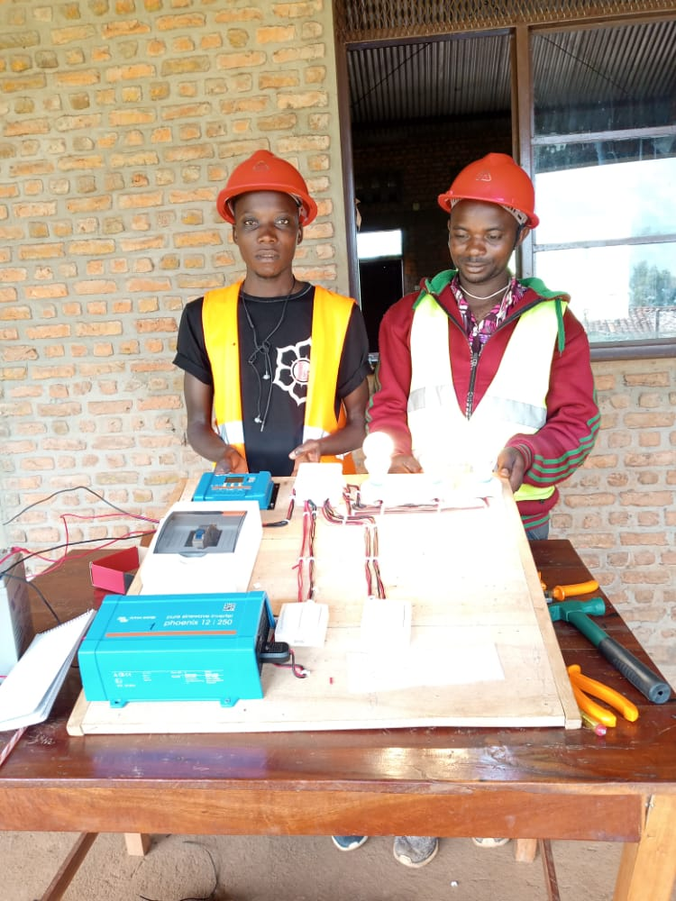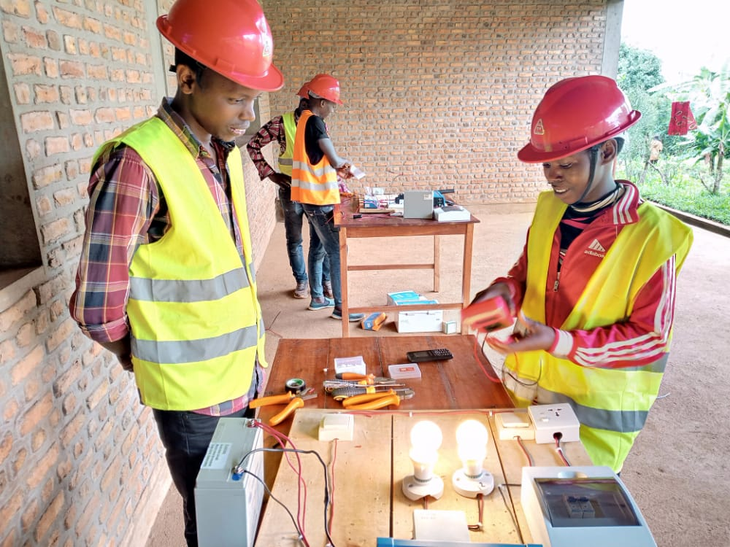
Another overview of PV systems components took place the very next day on October 6th. As the previous day was a first for a few participants, another detailed look at inverters, then charge controllers, and their main attributes was used to help ground the learners’ comprehension. Thus each individual was given a comprehensive workshop opportunity to explore thoroughly and ask questions before moving on to the next subject.
On Thursday October 7th, students were introduced to one of the most important tools for an electrician: the Multimeter. If operated properly, it makes for an unequalled difference during installation and maintenance through its data collection capabilities. By giving them multiple small exercises/quizzes, the teacher was able to share most of the important features of this device and how helpful it can be as related to each of the main PV system components they got to handle throughout them courses.
The third week began with Mr. Adelin’s lecture on electrical diagrams for lighting installations for the most common occurrences: simple lighting, two-way lighting, and double two-way lighting. In addition to the drawings and schematics explained, a functional demo unit was put together with the students so that they are shown all the building steps.
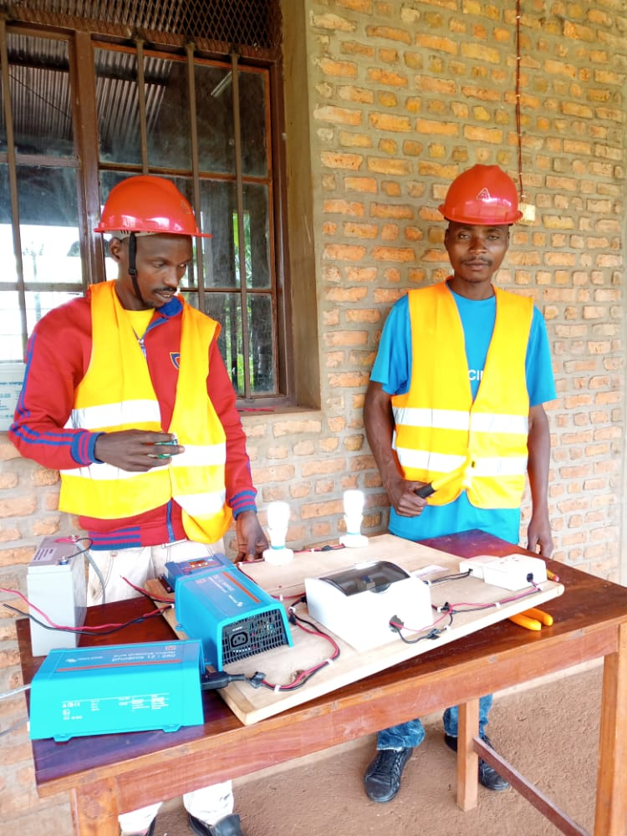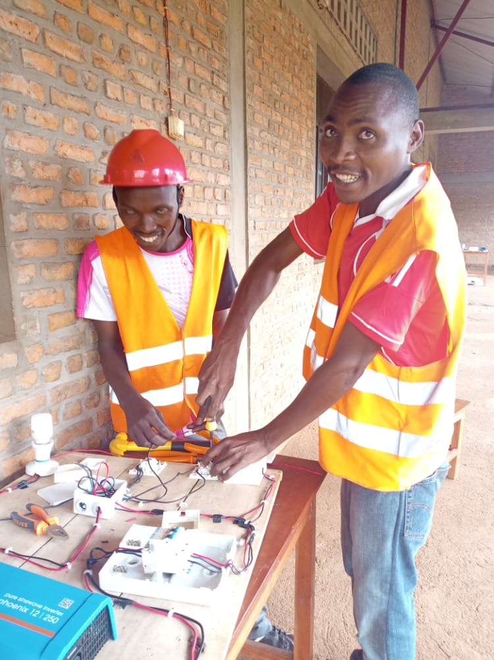
October 13th was a public holiday in commemoration of the 60th anniversary of the assassination of Prince Louis RWAGASORE. The day after, the curriculum continued onto the different types of cables and systems protection. Participants were taught about the need and benefits of proper protection throughout the system from energy production to its consumption. Due to the dangers of working with and around electrified objects, students have to increase their awareness of the risks involved and develop safe habits.
Therefore, Day 9 was held on Tuesday October 19th. This being one of the most important hands-on sessions, its aim is to avoid bad installation behaviors for lack of knowledge in order to minimize avoidable incidents. The instructor taught on electrification, electrocution, and what to do in case of an electricity-related accident. Any such occurrences need to be addressed swiftly and correctly. All the way to the following day, students were continuously shown examples of the proper way to react in order to avoid extensive damages and even death in the most extreme case scenarios.
Thursday October 21st was yet another public holiday, remembering another fallen hero, President Pierre NDADAYE. Homework was given to the participants in order to confirm status progress in the coursework.
On the 11th day, a site visit was organized by the teaching staff in order for students to experience more operational PV energy systems. Learners interacted with the users and each other by gathering information about the different system functions. They saw firsthand the necessity to understand the installations, communicate good usage practices to the end-users, and have a thorough maintenance schedule.
The next two sessions focused on hands-on sessions with the subject matter of proper install of lights and wall sockets. As most classmates had limited technical experience, the staff utilized these practical exercises so as to strengthen the technical capabilities of each member. Participants spent these two days assembling and disassembling lights, thus practicing how they would execute installations in houses and offices.
On Tuesday November 2nd, the instructor agreed to the students’ request to have more practice time and proceeded with an in-depth review and demonstration of how to install two-way lighting. The complexity of the wiring involved required the engineer to slowly explain and demonstrate the process to the learners. The day after, it was up to those being educated to successfully build their own models in teams of two.
On the 14th day of classes, the students executed the install of a long electrical line to be used to power an AC mill at the AKARARO Center. This exercise, though supervised by the teaching engineer, was entirely done by the students in order to push them to think over questions about cable type and fixation, wire support and protection, machinery phase input, breaker sizing, etc. They got to use specialized equipment in the available master toolbox while inquiring about the standard practices and guidelines around such work.
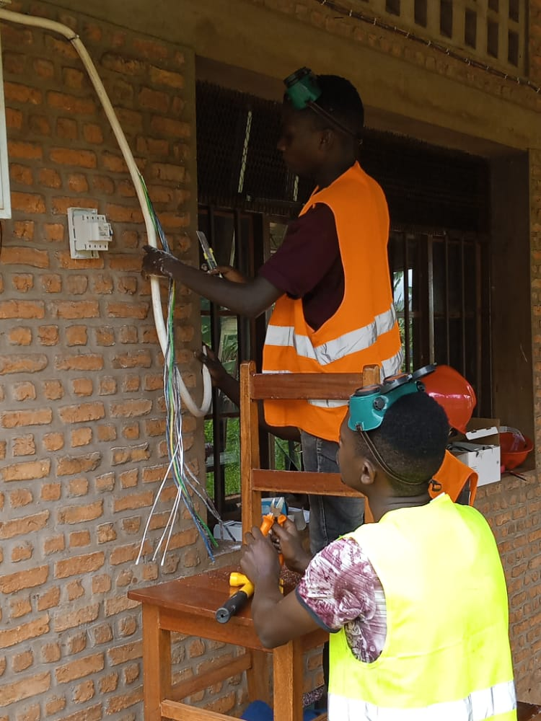
The following morning, another instructor lectured on the basics of entrepreneurship. The teaching staff felt strongly that each scholar needed to develop business-minded qualities such as creativity, willingness to learn and work hard, striving for structure while committing to continuous self-improvement. Students had some difficulty at first adjusting to the change of topic so it was decided to slow down a bit to allow them to absorb all these new concepts.
On Wednesday November 9th, the theme of entrepreneurship followed the lines of essential subjects that needed to be addressed. Attendees need not only rely on their newly acquired technical knowledge but also have to reach and convince potential clients, organize themselves into entities such as private firms, market themselves effectively, comply with the rules and regulations of the country, learn where to start and get advice from in order to open and operate a successful business.
Thursday November 11th was the final written evaluation. The commencement ceremony was held on the day after and certificates of course completion were handed out to each graduate with a passing grade, and a celebration followed after as with previous classes.
If this were the end, then it would have been just like all the previous sessions. However, this group went beyond the staff’s expectations. They materialized what was the program’s aspiration by connecting with graduates from previous sessions and created an organization of technicians which now has been recognized by the local authorities and is a legally registered business entity in Burundi. In it, these young men and women have put together their resources to purchase stock, produce a marketing strategy geared towards activities involving the local population to increase product and service visibility and popularity. This is a first, not only in MBUYE county, but in the entire Province of MURAMVYA; a testimony to the potential of this program as it is being recognized by local authorities and news outlets.
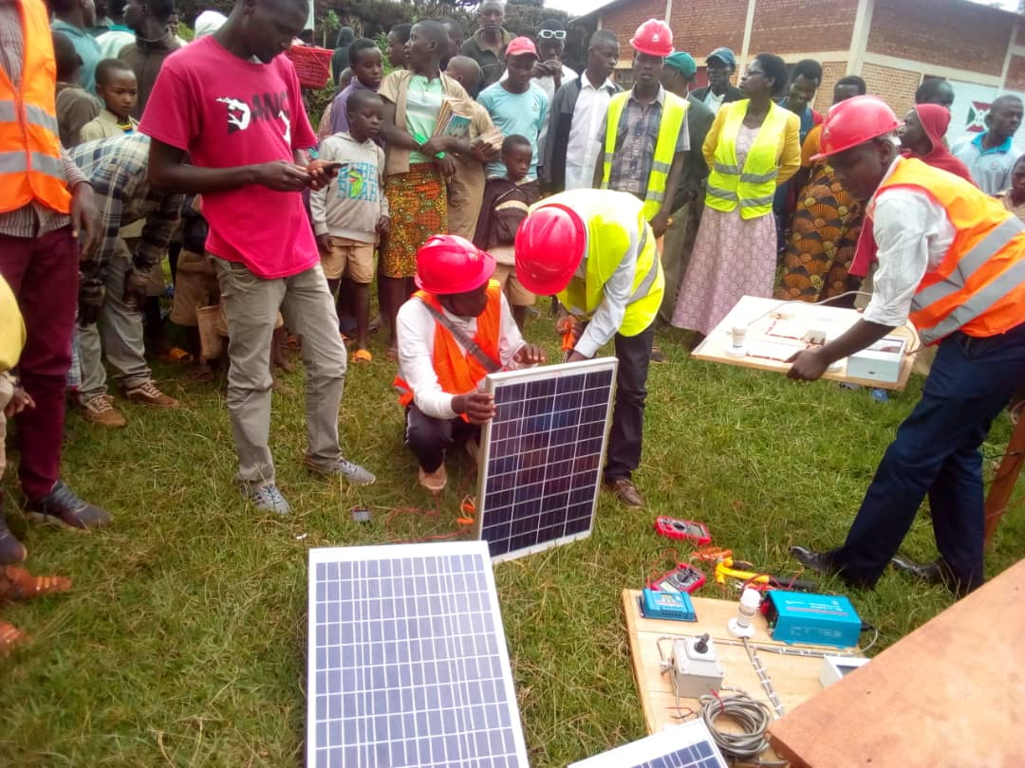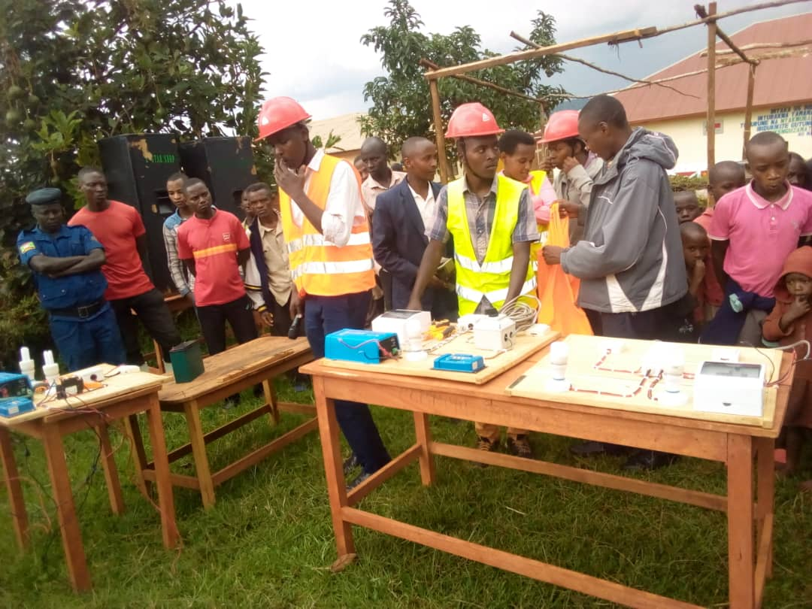
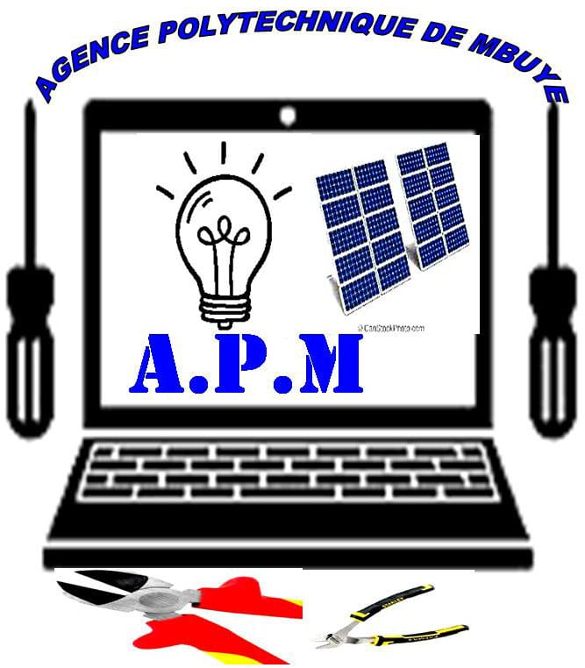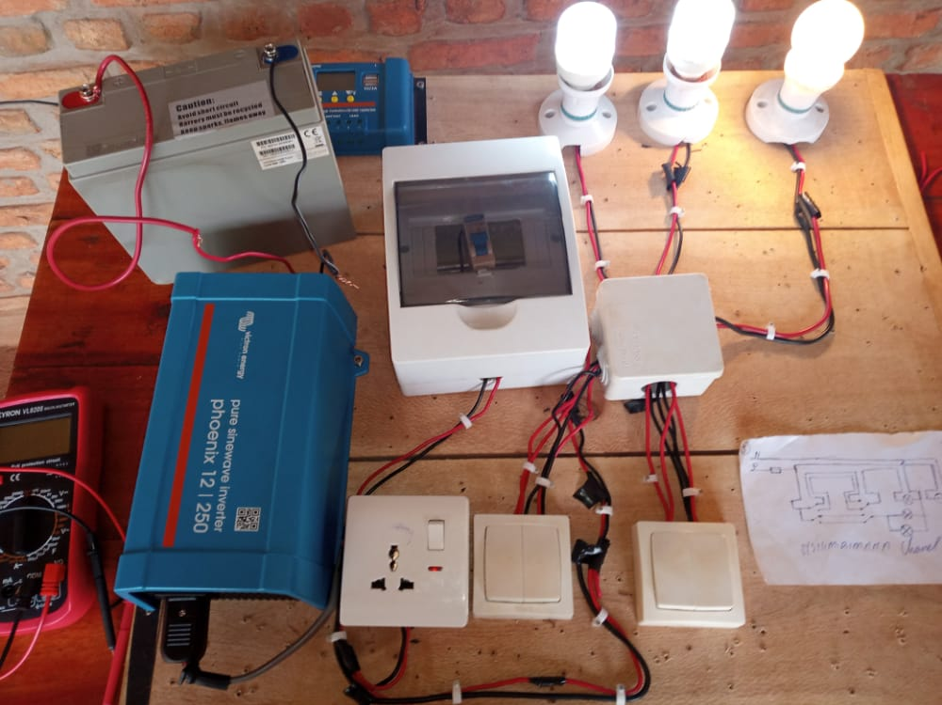
It has been a refreshing sight to see year-long effort yield such vivid results do so and in time for the Level 2 course programed early next year. This robust course aims to build upon the foundation laid out with the first curriculum with extensive knowledge for the top students selected from the first four groups of graduates.

